**Guidance for Volunteers Undertaking the [insert catchment name] Outfall Safari, [insert date]**

[Insert organisation logo]

**Weather and coordinating survey dates**

Rain and high river levels wash away the evidence of pollution, so we need 48 hours of no or only light rain in the catchment before conducting any survey work.

As rain can often interfere with planned survey dates, we ask that volunteers are flexible and can move survey dates when necessary. From experience of running surveys on other rivers we have found the best way to coordinate a complete survey of a river is via [insert name of communication tool you’ll use – closed Facebook group or WhatsApp for example]. The [insert name of communication tool] is [insert name of Facebook or WhatsApp group], you will be invited to join it after the training. The page provides the forum for arranging the detail of surveys, monitoring progress of the survey and asking questions. It’s important we coordinate so that we do not double survey some stretches of the river and we don’t miss reaches. Once you have completed your survey please share the start and end point on [insert name of Facebook or WhatsApp group] and let [insert manager’s name] know if any sections were inaccessible and therefore not surveyed.

**Health and safety working near water** [Please adapt where necessary]

Most of the survey work can and should be safely conducted from the riverside path, with the very occasional need to enter the river.

* Please do not go into a river deeper than wellington boot depth. Assess conditions of the river before doing so.
* Be cautious on the river bank of slips, trips and falls.
* Please do not touch the outfalls.
* Survey in a group with at least one other member carrying a mobile phone in case of an emergency.
* Carry a walking pole (or similar) to part vegetation such as brambles. Long trousers and sturdy footwear are recommended.
* Avoid giant hogweed. It can burn skin on contact (see photo below).
* Cover up cuts and abrasions in case of contact with water.

**About Outfall Safari**

Now that you’ve completed the Outfall Safari training, you’re ready to start surveying. Here is a guide to key things to remember when assessing outfalls:

1. Weather and coordinating survey dates
2. Health and safety working near water
3. The assessment method and reporting pollution
4. Contact details

Thank you for taking part.



*Giant* *hogweed*

**The assessment method**

**Outfalls are pipes entering the river and are generally of greater than 20cm diameter.**

**For all outfalls, whether polluted or not, an assessment form should be completed in the project app.**

**Please ensure only one person completes an assessment form at each outfall - it is important that multiple forms for a single outfall is avoided.**

The outfall assessment form has ten questions. Your assessment answers for each outfall will be converted into an **Impact Score** for the outfall.

**1)** **Volunteer name:** It is important that you include your names so that if there are any queries whilst processing the data, we know who to contact.

**2)** **Date of survey**

**3)** **GPS location:** Pleasestand as close as (safely) possible to the outfall when recording the GPS location.This may takealittle while to locate but be patient. Please try and get the location accurate.

**4)** **Photo of the outfall:** Clear photos of the outfall and associated impact help with processing and quality control of the data.

**5)** **Description of the nearest landmark:** It is helpful to be as descriptive as possible of the nearest landmark – what is the nearest road or identifiable building to the outfall, how many other outfalls can be seen from this location, is the surveyor standing on the same bank as the outfall, etc. If the surveyor is near a residential area, the nearest house number is also useful. The more location detail that is provided, the easier it is for follow up action to be taken on a polluted outfall.

**6) Which bank is the outfall on:** This should be left or right as you stand looking downstream.

**Signs of pollution include:**

* Sewage fungus. Seen as grey, often tufty growth on the river bed
* Foam or scum on the surface of the river
* Plume of discoloured water
* Sewage related debris e.g. sanitary products (“rag”)

**7) Ranking of the flow coming out of the outfall:** The categories for this; trickle (left), low (middle), moderate (right) and high flow, are quite subjective. Please use the photos below as a guide;

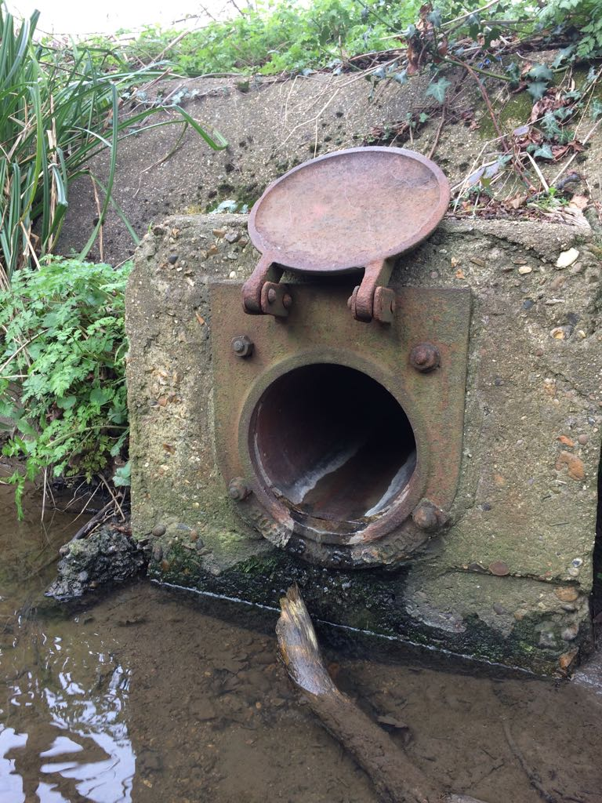 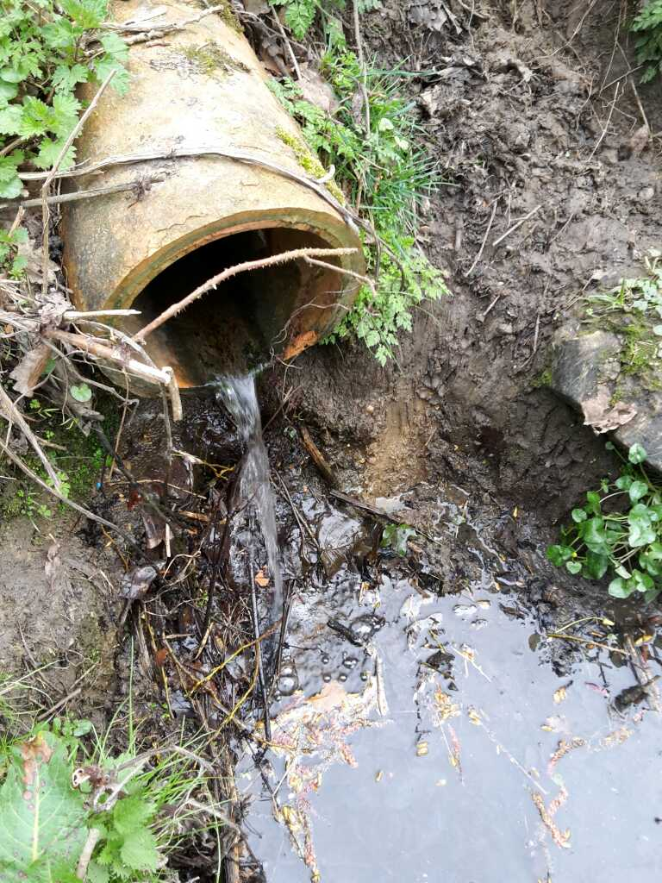 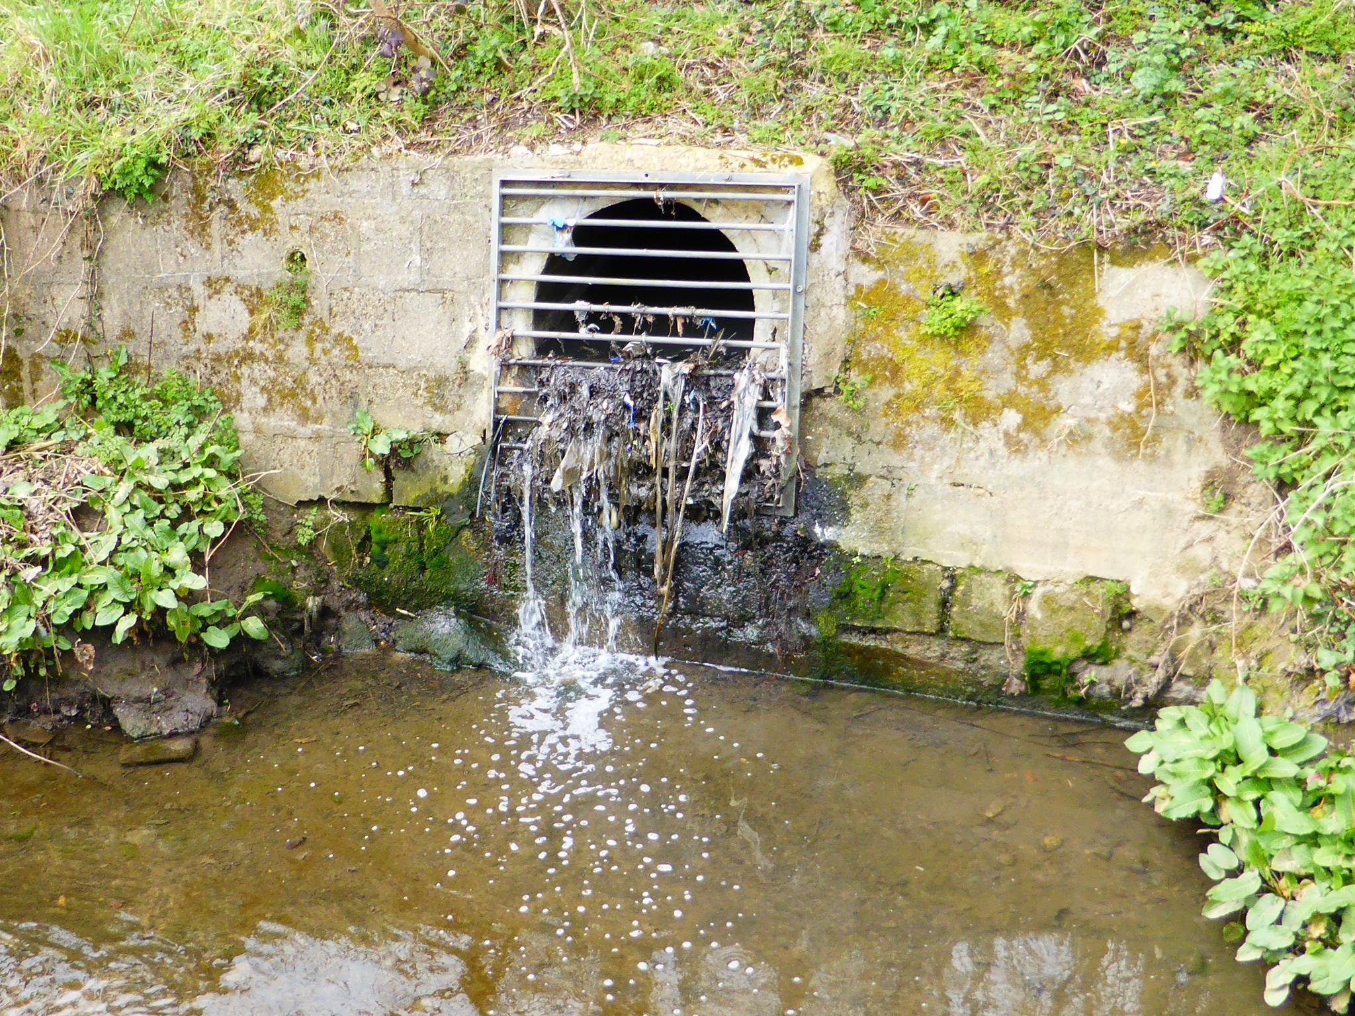

You can approximate the flow categories as:

* Tickle: < 0.1 l/s (or enough to fill a teacup in a minute).
* Low flow: Between 0.1 and 1 l/s (or enough to fill a bucket in a minute).
* Moderate flow: 1 to 2 l/s (more than a bucket full each minute).
* High flow: Clearly >2 l/s (more than a bath tub in a minute).

**Still assess outfalls with no flow.**

**8) Ranking of the visual impact of the outfall:** How far from the outfall can you see signs of pollution? Please use the photos below as a guide to the different signs of pollution.

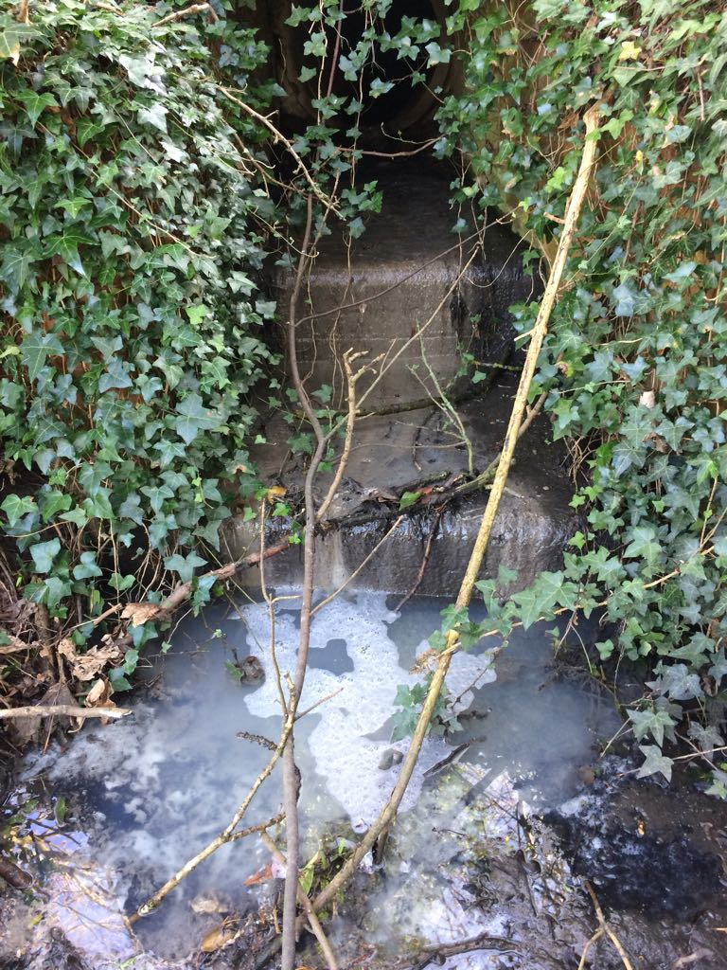 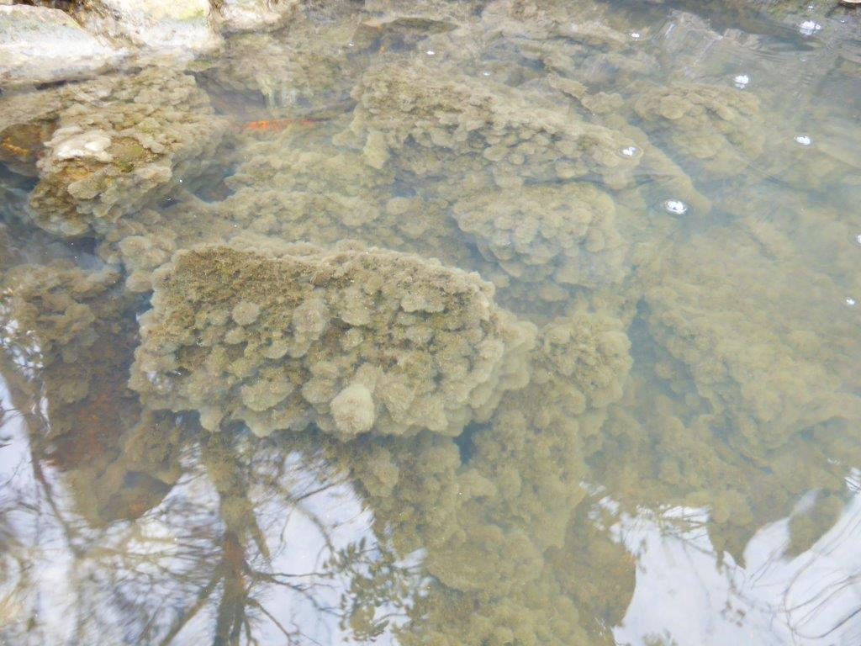

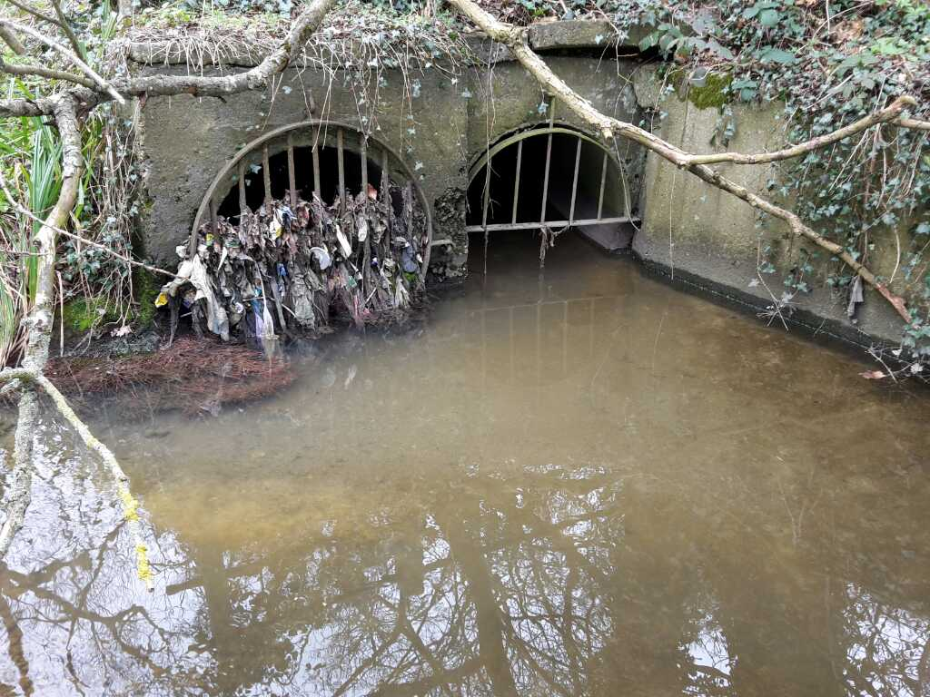

**9) Ranking of the aesthetics of the outfall:** Please tick the category that most closely matches what you see at the outfall you are assessing (there might not be a perfect fit).

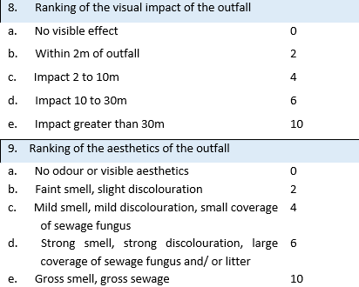

**10) Other signs of pollution:** Free text can be used to describe pollution that is not covered by earlier questions. If you can see other forms of pollution from an outfall, please provide details.

* What colour is the water?
* Is oil or fat present? If yes, what colour?
* Is food waste present?
* Are silt/construction materials present etc.

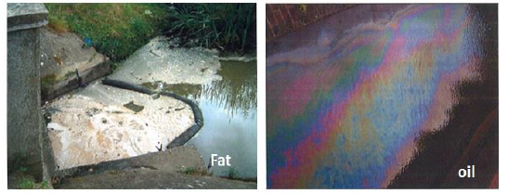

**Once you have answered the questions make sure you save the form you have filled in before moving onto the next.**

**Uploading the data you have collected:**

You don’t need an internet connection to fill in the forms and collect data. You can store each form on the app and then upload them all onto the database when you next connect to the internet. To upload your forms and photos press the upload icon on your app (the app will congratulate you once you have uploaded all the data).

© Environment Agency

**Contact details**

[Insert organisation project manager/s contact details]

**Reporting pollution from the river** [Update this to suit your local scenario]

If the outfall scores 10 or above i.e. greater than 10-meter impact zone and strong smell, discolouration, large coverage of sewage fungus and/or litter, it needs to be called in from the field to the water company.

[Insert water company phone number]

When you call in please include the following details:

* Say you are a trained volunteer helping with Outfall Safari
* Describe the visual and aesthetic impact
* Say you have a photo and it will be included in a report on the survey
* Give a grid reference (if you can) and which bank of the river it is on
* Any additional description of the pollution

Please take the [insert regional water company] reference number for any pollution reports and pass to [insert managers email].

If you can see pollution coming from any other sources, please call it into the Environment Agency (EA) on 0800 80 70 60.