Replace cover photos with your own from your survey
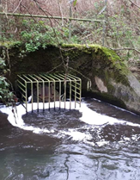
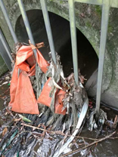
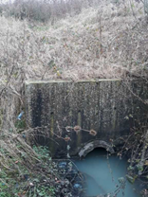

Outfall Safari

An audit of the surface water outfalls in the <your river name>

<Date>

Revision History
Revision Ref / Date Issued | Amendments | Issued to

Acknowledgements
This project, funded by <funders>, and part of <your project> project, has been delivered by <lead organisation> in partnership with <partners>. It would not have been possible without the help of all the dedicated volunteers who collected the data and Alan Graham’s work for TRT to link with volunteers and fill gaps. The outfall safari methodology has been developed by Zoological Society of London, and further developed by The Rivers Trust.

Logos here

Contents

1 Introduction 4
2 Aims 6
3 Method 6
4 The App 7
4.a Conversion of outfall assessment to impact scores 8
4.b Reporting and thresholds 8
4.c Data Processing 8
5 Results 9
6 Volunteer feedback 24
7 Discussion 25
8 Future Surveys 26
9 Conclusions 26
10 Contact details 27
11 References 27
12 Appendices 27

Introduction
Misconnected wastewater pipework, cross-connected sewers and combined sewer overflows are a chronic source of pollution in urban rivers, sending pollution, via outfalls, into the nearest watercourse. At the moment there is no systematic surveying of outfalls in rivers to identify sources of pollution and to notify the relevant authorities. The Outfall Safari is a survey method devised to address this evidence gathering and reporting gap. It was created by the Citizen Crane project steering group which consists of staff of Thames Water, Environment Agency (EA), Crane Valley Partnership, Friends of River Crane Environment, Frog Environmental and the Zoological Society of London (ZSL). It was first used on the River Crane in 2016.
<Insert introduction to the river, major impacts and any WFD information or other assessment of current ecological status and water quality>.
<your organisation> and Environment Agency (EA) have conducted detailed monitoring of water quality along <your river> (ref). This has shown that the main pollution sources appear to be <insert relevant detail about sources here>.
<water company> is conducting detailed investigations, using modelling and sondes and has supported the Outfall Safari as a potentially valuable additional source of data.
<insert project information and other partners>.
fig 1. Location map.
<insert location map>
Fig 2. Project area
<Detailed catchment map>

Aims
The aims of the <your river> Outfall Safari were to:
- record and map the dry weather condition behaviour of surface water outfalls in the urban parts of <your river>.
- assess the impact of the outfalls and report those that are polluting to the Environment Agency and <water company>
- build evidence on the scale of the problem of polluted surface water outfalls in the wider area
- recruit more volunteers and further engage existing volunteers in the work of the <lead organisation>.

Method
The survey of outfalls was conducted between <dates>. <number> people took part in the Outfall Safari, comprising <number> volunteers and <number> members of <lead organisation> staff. Volunteers were trained at the <location and date of training> and were given:
- an overview of water quality issues in the <your river> catchment
- information on outfalls and how they become polluted
- instruction on how to assess each outfall using the project App and how to upload information to the database
- a health & safety briefing and signing of the risk assessment
During the training, groups of volunteers were assigned lengths of river to survey. Further coordination of survey dates and reaches was conducted by the volunteer group on a closed Facebook group set up specifically for the Outfall Safari. Groups of volunteers were free to conduct the survey of their reach when convenient to them, within the survey period, provided there had been no rain for 48 hours prior to survey.
A period of 48 hours of no rain is required before any survey work as rainfall and high surface water flows can obscure the negative impacts of outfalls by washing away sewage fungus, discoloured sediments and rag. In addition, many <water company> outfalls should only convey rain water. Therefore, any flow in dry weather conditions, no matter how small, was of concern to <water company>.
The survey work was conducted from the riverside path or banks. The risk assessment for riverside outfall surveying highlighted that volunteers should not enter the river channel to undertake the survey. In addition to personal protective equipment (PPE) volunteers took a printed handout, designed to help with ranking the impacts of each outfall, a smart phone or tablet loaded with a specially created data entry App and printed maps showing known surface water outfalls and Combined Sewage Overflows.

The App
For ease of data collection from the river, the volunteers used an app created in Epicollect5 (https://five.epicollect.net ). Created by researchers at Imperial College, Epicollect is free and openly available. Once a project is set up in Epicollect5 it provides an app for remote data collection and upload, usable on GPS enabled smart phones, and a web portal to access and download the data. The outfall assessment form created in the app consisted of eleven questions for volunteers to fill in at each outfall. The questions were taken from the form that ZSL developed for the River Crane, adapted in consultation with <water company> and the Environment Agency, and are shown in Table 1.
Table 1 – Questions used in the Epicollect App to assess each outfall and their corresponding Impact Score
Question | Options | score
1. Volunteer name
2. Date of survey
3. GPS location
4. Photo of the outfall
5. Description of the nearest landmark
6. Which bank is the outfall on (when looking downstream)
7. Ranking of the discharge coming out of the outfall
 | a. No Flow
 | b. Trickle
 | c. Low Flow
 | d. Moderate Flow
 | e. High Flow
8. Ranking of the visual impact of the outfall
 | a. No visible effect | 0
 | b. Within 2m of outfall | 2
 | c. Impact 2 to 10m | 4
 | d. Impact 10 to 30m | 6
 | e. Impact greater than 30m | 10
9. Ranking of the aesthetics of the outfall
 | a. No odour or visible aesthetics | 0
 | b. Faint smell, slight discolouration | 2
 | c. Mild smell, mild discolouration, small coverage of sewage fungus | 4
 | d. Strong smell, strong discolouration, large coverage of sewage fungus and/ or litter | 6
 | e. Gross smell, gross sewage | 10
10. Is there any sewage related debris visible? Y/N
11. Other signs of pollution free text N/A

Conversion of outfall assessment to impact scores
To assist with prioritisation of the outfalls, the Environment Agency in London had provided a method of converting the assessment data to a numeric impact score for each outfall. This was adopted for this study after consultation with the addition of a presence/absence question for sewage related debris. These scores are shown in the right hand column in Table 1. The scores for questions 8 and 9 were added to give an Impact Score.

Reporting and thresholds
Any outfall with an Impact Score ≥ 10 was reported directly from the river to the Environment Agency’s Incident Hotline and <water company>. Those scoring 0 are shown with a green flag, 1 to 9 as amber and 10 or over as red. These thresholds were decided jointly with <water company>, and it was very positive that <water company>were keen to know about all polluting outfalls scoring over 0. <water company>were also keen to know if any sewage related debris was present, and this is shown on the same maps on a presence or absence basis.
Further analysis is provided in the Discussion section.

Data Processing
Outfall data were checked to remove double entries and mapped using ArcGIS Desktop in the maps below.

Results
The volunteers photographed, located and assessed a total of <number> outfalls. Of this total <number> showed some signs of pollution and scored ˃ 0 and of these <number> were significantly polluting with a score ≥ 6. The locations of these outfalls are shown in Maps 1 to 8. The details of the outfalls with an impact score of > 0 are given in Table 2 and their numbers are shown on the yellow or red flags in the maps below.
The full dataset is available from <lead organisation>.
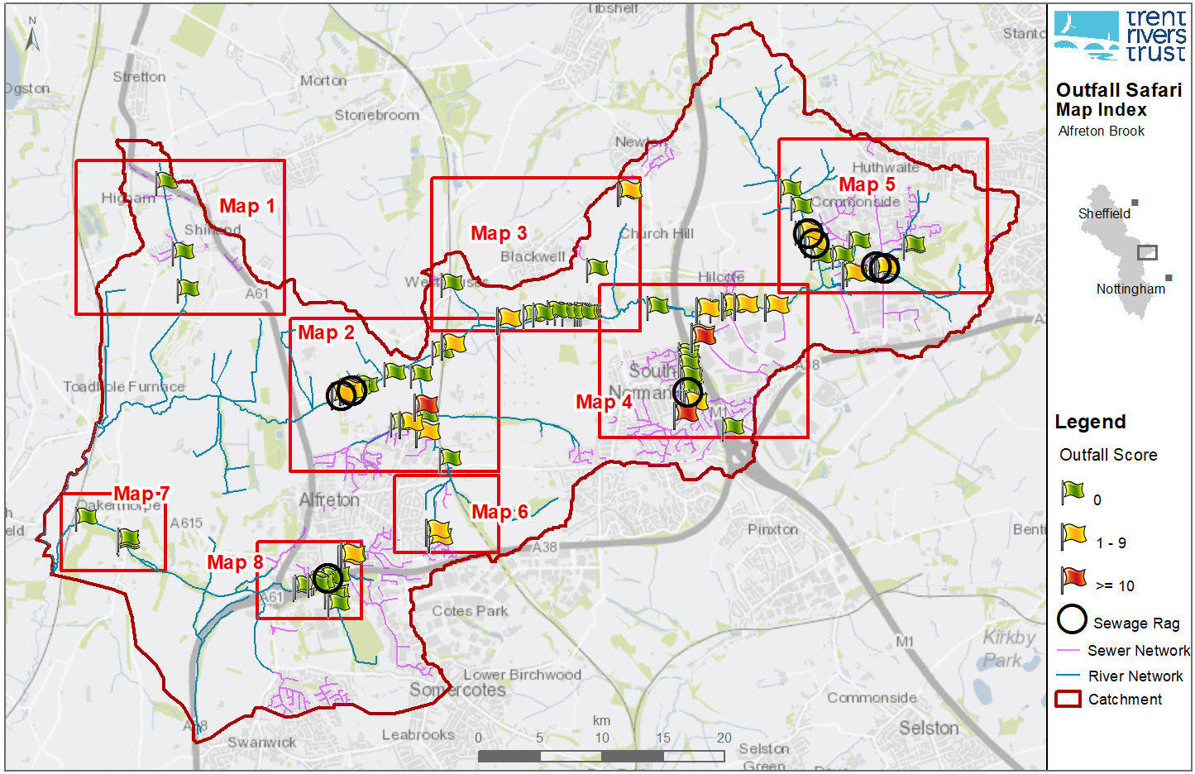
Figure 3 – example index map from Alfreton Brook <use Outfall Safari Template.mxd to produce a similar map>

Contains Environment Agency information © Environment Agency and/or database right. Contains Ordnance Survey data © Crown copyright and database right 2017

Figure 4 - example index map from Alfreton Brook <use Outfall Safari Template.mxd to produce a similar map>
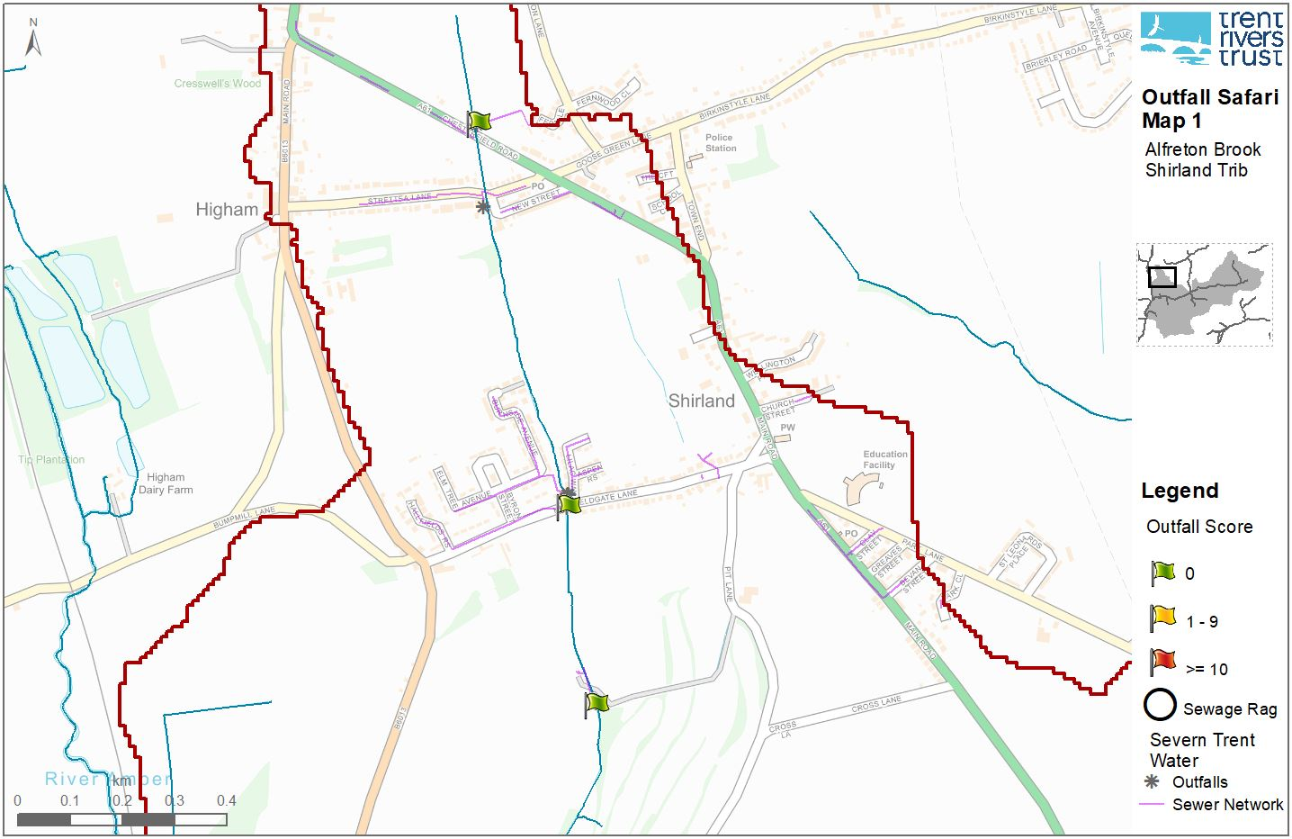
Contains Environment Agency information © Environment Agency and/or database right. Contains Ordnance Survey data © Crown copyright and database right 2017

Table 2 Details and photos of outfalls shown in figures 1 to 9.
Only outfalls with an impact score of > 0 are included in the table
Example data from Alfreton Brook. <Insert your own data by exporting to csv from EpiCollect or ArcGIS. Photos need to be inserted manually in to the table>
ID | Location | NGR | Bank | Outfall Score | Photo
4 | David Nieper school Alfreton | SK4130455170 | Right | 4 | 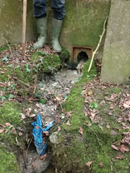
7 | David Nieper school Alfreton | SK4132655196 | Left | 4 | Not recorded
11 | Thurston Way | SK4420158968 | Right | 4 | 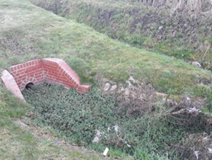
27 | U/s Ball Hill Rd | SK4488756768 | Right | 4 | 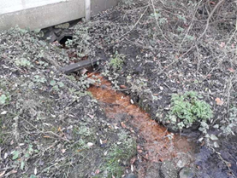
30 | Outfall below sports pitches | SK4478856660 | Left | 12

Volunteer feedback
The volunteers were asked to give feedback on:
- What went well?
- What could be improved? Any advice for next time?
- Any other comments?
<insert number> volunteers and <insert number> staff member gave feedback.

<insert feedback summary and quotes>

A feedback session was held for volunteers, with input from <partners>. This was also a good way of engaging partner organisations in the finding.

Discussion
This report represents an audit of how outfalls within the surveyed areas of the <your river> catchments were behaving during the survey. However, some outfalls pollute intermittently and may not have been detected as a problem during the survey.
In total there are <insert number> km of river in the <your river> Catchments. This Outfall Safari surveyed <insert number> % of this length comprising the urban sections and those impacted by urban areas. <insert number> of the <insert number> outfalls were recorded as having a detrimental impact. <insert number> were recorded with impact scores of 2-4, <insert number> with scores of 6-9 and <insert number> with scores of ≥ 10 These were reported to <water company>, followed up and feedback given.
Figure 12

Not all of the outfalls with impact scores appear to be associated with <water company>, assets.
Some outfalls marked as ‘green’ have previously been seen to be polluting. We will monitor them occasionally and report if polluted.
Not all of the outfalls were accessible. For example several on Map <insert number> could not be accessed as it was a building site.

Future Surveys

Conclusions
The Outfall Safari has provided an inventory, with photographs, impact scores and locations of <insert number> outfalls, of which over <insert number> % were bringing some pollution to the water courses at the time of the survey. It has engaged volunteers with this issue and they would be willing and able to identify and report pollution incidents in future. It has also enhanced working relationships between < organisation> and <water company>, providing a tangible and useful focus which engaged both operational and strategic staff, as well as consultants carrying out detailed modelling on their behalf.
The dataset has been shared with <water company>, and EA, and also with the Coal Authority and researchers at <insert name> University. Feedback from consultants working for <water company>, and from researchers is that the dataset is a useful resource to complement their studies.
<water company>, followed up the three ‘red’ outfalls that were reported. <organisation> are keen to ensure that all sources of pollution are traced and dealt with, to improve water quality locally and within the wider <your river> catchment. We understand that prioritisation is necessary, and we hope that this study will help to prioritise activities. We request a response from <water company>, and EA to our findings in relation to all of the ‘Amber’ and ‘Red’ outfalls.

Contact details
<name> (Project Manager), <organisation> <email>

References
<insert as required>

